* Antes de que el servidor cierre la conexión por falta de comunicación:

Las solicitudes fueron movidas al url

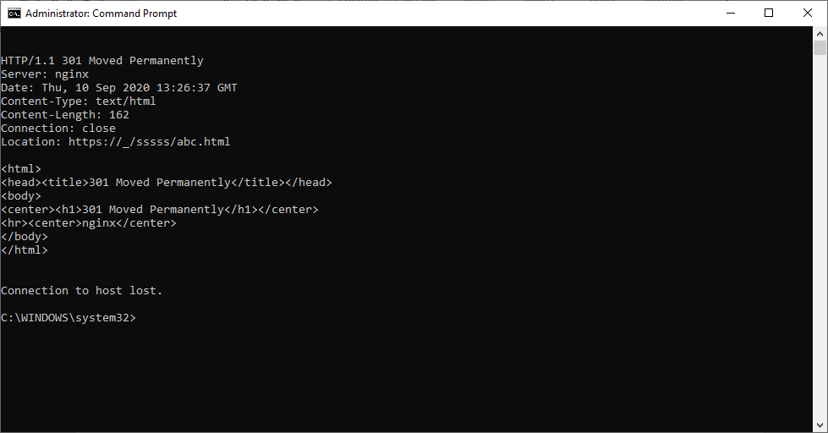

* ¿Qué otros tipos de error existen?
  + 1xx respuesta informativa: se recibió la solicitud, proceso continuo
  + 2xx con éxito: la solicitud se recibió, comprendió y aceptó correctamente
  + Redirección 3xx: se deben realizar más acciones para completar la solicitud
  + Error de cliente 4xx: la solicitud contiene una sintaxis incorrecta o no se puede cumplir
  + Error de servidor 5xx: el servidor no cumplió con una solicitud aparentemente válida

• Realice una nueva conexión con telnet, esta vez a:

La petición se cumplió de manera satisfactoria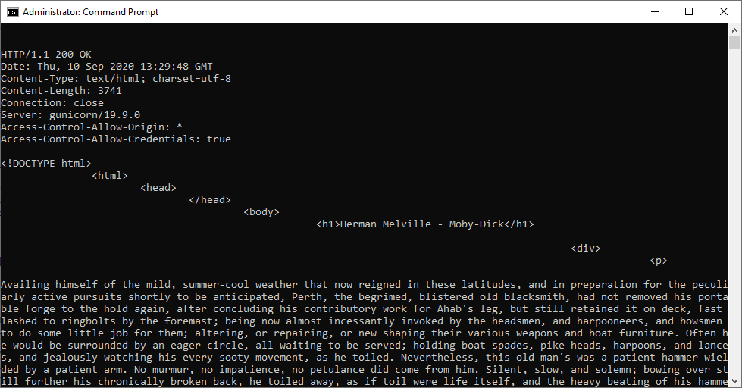

Al realizar la petición, nos encontramos con este archivo html

Al realizar el conteo encontramos esto:

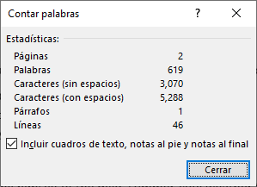

<!DOCTYPE html> <html> <head> </head> <body> <h1>Herman Melville - Moby-Dick</h1> <div> <p> Availing himself of the mild, summer-cool weather that now reigned in these latitudes, and in preparation for the peculiarly active pursuits shortly to be anticipated, Perth, the begrimed, blistered old blacksmith, had not removed his portable forge to the hold again, after concluding his contributory work for Ahab's leg, but still retained it on deck, fast lashed to ringbolts by the foremast; being now almost incessantly invoked by the headsmen, and harpooneers, and bowsmen to do some little job for them; altering, or repairing, or new shaping their various weapons and boat furniture. Often he would be surrounded by an eager circle, all waiting to be served; holding boat-spades, pike-heads, harpoons, and lances, and jealously watching his every sooty movement, as he toiled. Nevertheless, this old man's was a patient hammer wielded by a patient arm. No murmur, no impatience, no petulance did come from him. Silent, slow, and solemn; bowing over still further his chronically broken back, he toiled away, as if toil were life itself, and the heavy beating of his hammer the heavy beating of his heart. And so it was. Ç Most miserable! A peculiar walk in this old man, a certain slight but painful appearing yawing in his gait, had at an early period of the voyage excited the curiosity of the mariners. And to the importunity of their persisted questionings he had finally given in; and so it came to pass that every one now knew the shameful story of his wretched fate. Belated, and not innocently, one bitter winter's midnight, on the road running between two country towns, the blacksmith half-stupidly felt the deadly numbness stealing over him, and sought refuge in a leaning, dilapidated barn. The issue was, the loss of the extremities of both feet. Out of this revelation, part by part, at last came out the four acts of the gladness, and the one long, and as yet uncatastrophied fifth act of the grief of his life's drama. He was an old man, who, at the age of nearly sixty, had postponedly encountered that thing in sorrow's technicals called ruin. He had been an artisan of famed excellence, and with plenty to do; owned a house and garden; embraced a youthful, daughter-like, loving wife, and three blithe, ruddy children; every Sunday went to a cheerful-looking church, planted in a grove. But one night, under cover of darkness, and further concealed in a most cunning disguisement, a desperate burglar slid into his happy home, and robbed them all of everything. And darker yet to tell, the blacksmith himself did ignorantly conduct this burglar into his family's heart. It was the Bottle Conjuror! Upon the opening of that fatal cork, forth flew the fiend, and shrivelled up his home. Now, for prudent, most wise, and economic reasons, the blacksmith's shop was in the basement of his dwelling, but with a separate entrance to it; so that always had the young and loving healthy wife listened with no unhappy nervousness, but with vigorous pleasure, to the stout ringing of her young-armed old husband's hammer; whose reverberations, muffled by passing through the floors and walls, came up to her, not unsweetly, in her nursery; and so, to stout Labor's iron lullaby, the blacksmith's infants were rocked to slumber. Oh, woe on woe! Oh, Death, why canst thou not sometimes be timely? Hadst thou taken this old blacksmith to thyself ere his full ruin came upon him, then had the young widow had a delicious grief, and her orphans a truly venerable, legendary sire to dream of in their after years; and all of them a care-killing competency. </p> </div> </body> </html>

* En la práctica no se utiliza telnet para hacer peticiones a sitios web sino el comando curl con ayuda de la línea de comandos:

Con “curl -v” nos saldrá una advertencia sobre los errores que se puedan encontrar en la consulta, pero solo aparecerá una advertencia, nada más.

Con “curl -i” incluye los encabezados de respuesta en la salida, entre estos va nombre del servidor, cookies, fecha del documento, versión HTTP, entro otros.

Parte 2

1. Revise la clase SampleServlet incluida a continuación, e identifique qué hace:

La clase SampleServlet se encarga de eatender las peticiones de un determinado cliente y entrega su respectiva respuesta, en este caso será “Hola Mundo”.

1. En el pom.xml, modifique la propiedad "packaging" con el valor "war".

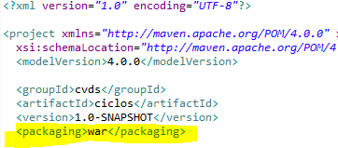

1. Revise en el pom.xml para qué puerto TCP/IP está configurado el servidor embebido de Tomcat (ver sección de plugins).

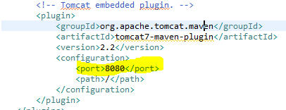

1. Compile y ejecute la aplicación en el servidor embebido Tomcat, a través de Maven con:

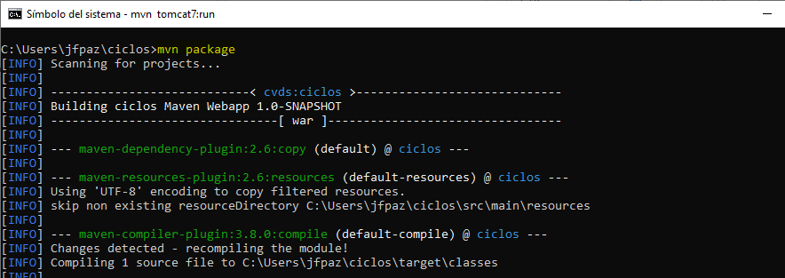

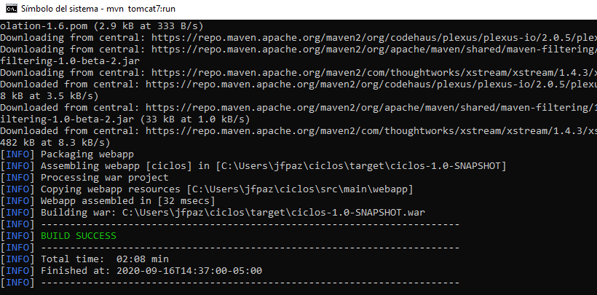

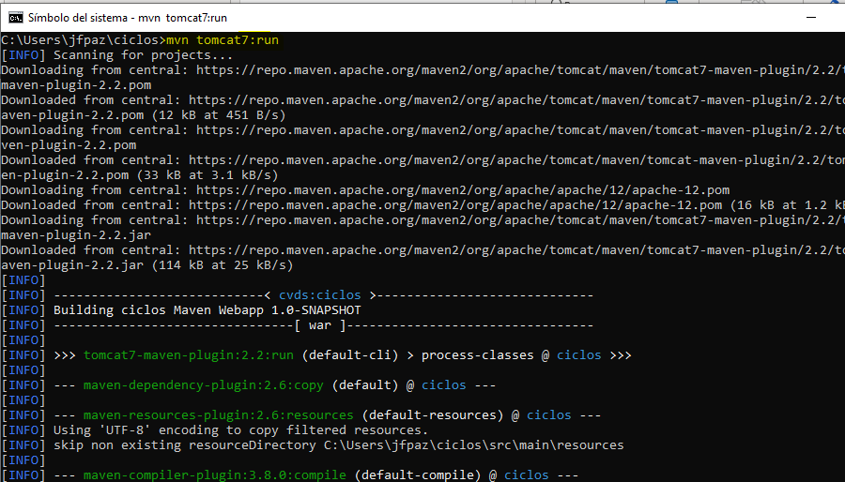

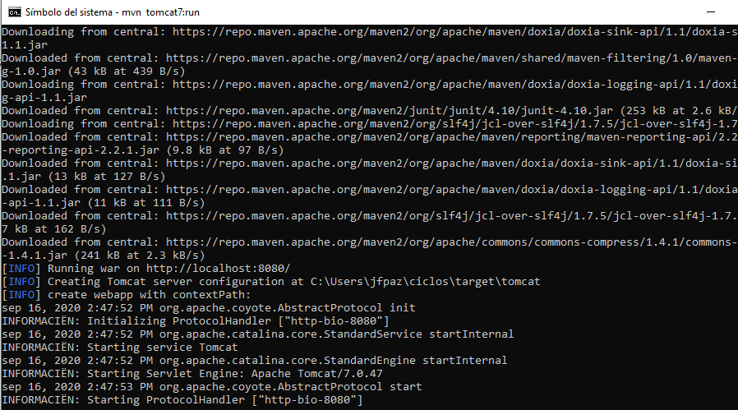

1. Abra un navegador, y en la barra de direcciones ponga la URL con la cual se le enviarán peticiones al ‘SampleServlet’. Tenga en cuenta que la URL tendrá como host ‘localhost’, como puerto, el configurado en el pom.xml y el path debe ser el del Servlet. Debería obtener un mensaje de saludo.

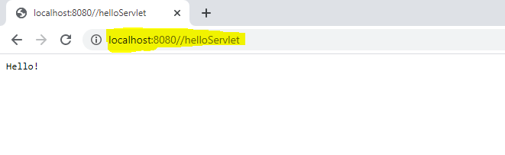

1. Observe que el Servlet ‘SampleServlet’ acepta peticiones GET, y opcionalmente, lee el parámetro ‘name’. Ingrese la misma URL, pero ahora agregando un parámetro GET

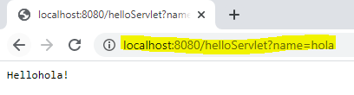

1. Busque el artefacto gson en el repositorio de maven y agregue la dependencia

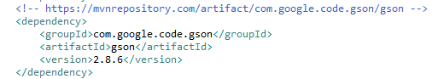

1. En el navegador revise la dirección https://jsonplaceholder.typicode.com/todos/1. Intente cambiando diferentes números al final del path de la url.

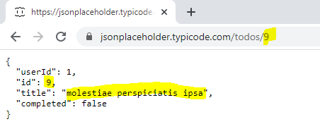

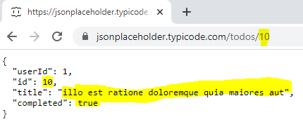

1. Basado en la respuesta que le da el servicio del punto anterior, cree la clase edu.eci.cvds.servlet.model.Todo con un constructor vacío y los métodos getter y setter para las propiedades de los "To Dos" que se encuentran en la url indicada.

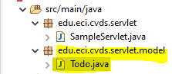

1. Intente hacer diferentes consultas desde un navegador Web para probar las diferentes funcionalidades.

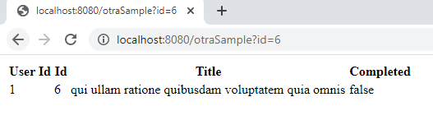

**Bibliografía**

**Hypertext Transfer Protocol -- HTTP/1.1**

. tools ietf. <https://tools.ietf.org/html/rfc2616#page-31>

# curl.1 the man page

. curl. https://curl.haxx.se/docs/manpage.html